AZURE FUNDAMENTALS

Create an Azure account

-Microsoft Learning

Disclaimer: The information contained in this document is completely owned and published by Microsoft Learning. I claim no credits to any of the content as I have just accumulated the available information for ease of read and learning. This document is/will/should not be used for any revenue systems.

Contents

Introduction 3

Learning objectives 3

Prerequisites 3

Azure accounts and subscriptions 3

What is an Azure account? 3

What is an Azure subscription? 4

Subscription types 4

Summary 5

Using multiple Azure subscriptions 5

Access management 5

Billing 6

Authenticate access with Azure Active Directory 7

Exercise - Create an Azure account 9

Sign up for a free account 9

Azure support options 10

Paid Azure support plans 10

Support-plan availability and billing 12

Other support options 12

Summary 13

Learn more 13

# Introduction

To create and use Azure services, you will need an Azure account. The account is free, and it allows you to build and deploy cloud-based applications, utilize sophisticated artificial intelligence services, and extract essential insights from your data.

With an Azure account, you can use a variety of free and paid services to create the next-generation architecture for your product and users.

## Learning objectives

In this module, you will:

* Learn about the different types of Azure accounts and subscriptions
* Understand how billing works in Azure
* Create a free Azure account
* Learn how to get help when you need it

## Prerequisites

* Knowledge of basic cloud computing terms and concepts
* A valid credit card to register with Azure

Note

An Azure Account is not required to take the free training provided by Microsoft Learn. Creating an Azure account is optional; you can complete this Learn module without creating an account.

(I still recommend creating an Azure Account)

# Azure accounts and subscriptions

With a free Azure account and subscription, you can build, test, and deploy enterprise applications, create custom web and mobile experiences, and gain insights from your data through machine learning and powerful analytics.

## What is an Azure account?

An Azure account is tied to a specific identity and holds information like:

* Name, email, and contact preferences
* Billing information such as a credit card

An Azure account is what you use to sign in to the Azure website and administer or deploy services. Every Azure account is associated with one or more subscriptions.

## What is an Azure subscription?

An Azure subscription is a logical container used to provision resources in Microsoft Azure. It holds the details of all your resources like virtual machines, databases, etc.

### Subscription types

Azure offers free and paid subscription options to suit different needs and requirements. The most commonly used subscriptions are:

* Free
* Pay-As-You-Go
* Enterprise Agreement
* Student

#### Azure free subscription

An Azure free subscription includes a **$200 credit** to spend on any service for the first 30 days, free access to the most popular Azure products for 12 months, and access to more than 25 products that are always free. This is an excellent way for new users to get started. To set up a free subscription, you need a phone number, a credit card, and a Microsoft account.

Note

Credit card information is used for identity verification only. You won’t be charged for any services until you upgrade.

#### Azure Pay-As-You-Go subscription

A Pay-As-You-Go (PAYG) subscription charges you monthly for the services you used in that billing period. This subscription type is appropriate for a wide range of users, from individuals to small businesses, and many large organizations as well.

#### Azure Enterprise Agreement

An Enterprise Agreement provides flexibility to buy cloud services and software licenses under one agreement, with discounts for new licenses and Software Assurance. It's targeted at enterprise-scale organizations.

#### Azure for Students subscription

An Azure for Students subscription includes **$100 in Azure credits** to be used within the first 12 months plus select free services without requiring a credit card at sign-up. You must verify your student status through your organizational email address.

## Summary

Whether you are an individual, a small business, an enterprise, or a student, you need a subscription to use Azure services. The typical sequence is to start with a free subscription so that you can evaluate Azure services. When your trial period expires, you will convert from the free subscription to Pay-As-You-Go.

# Using multiple Azure subscriptions

You can create multiple subscriptions under a single Azure account. This is particularly useful for businesses because access control and billing occur at the **subscription level**, not the account level.

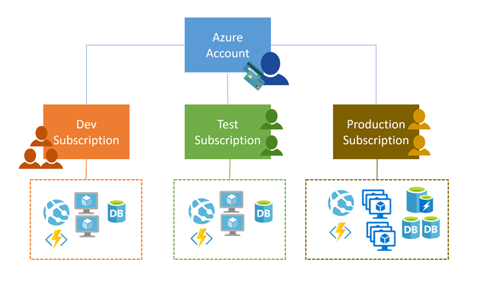

## Access management

You can create separate subscriptions on your Azure account to reflect different organizational structures. For example, you could limit engineering to lower-cost resources, while allowing the IT department a full range. This design allows you to manage and control access to the resources that users provision within each subscription.

Important

Subscriptions are also bound to some hard limitations. For example, the maximum number of Express Route circuits per subscription is 10. Those limits should be considered as you create subscriptions on your account. If there is a need to go over those limits in particular scenarios, then additional subscriptions may be needed.

## Billing

One bill is generated for every Azure subscription on a monthly basis. The payment is charged automatically to the associated account credit or debit card within 10 days after the billing period ends. On your credit card statement, the line item would say **MSFT Azure**.

Note

Subscriptions are billed independently, but the account owner is responsible for payment. In the case of "Pay-as-you-go" subscriptions, the account credit card will be charged for all associated subscriptions.

You can analyze your bill in the Azure portal - this will provide access to all your invoices, as well as a cost analysis breakdown of what got charged each month.

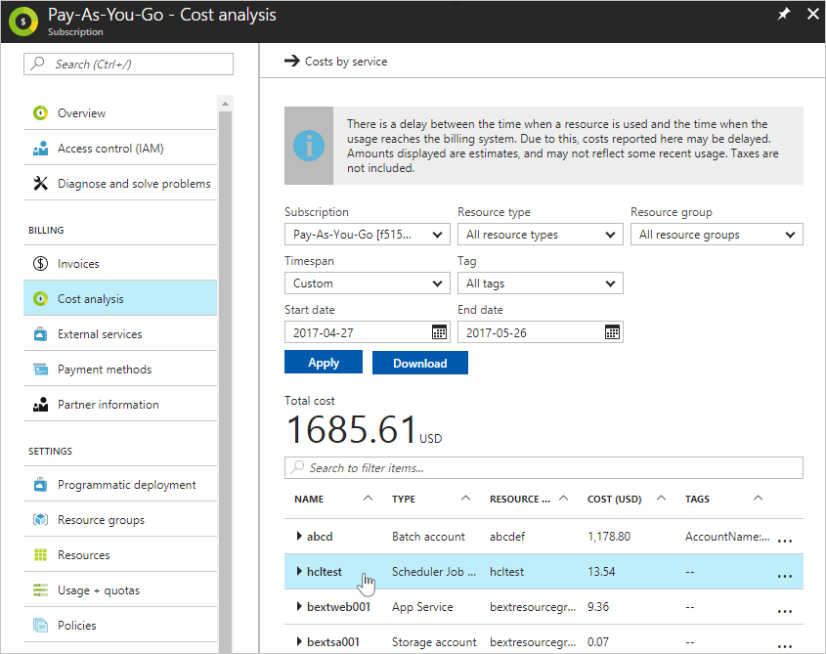

You can set spending limits on each subscription to ensure you aren't surprised at the end of the month. Reports can be generated by subscriptions, if you have multiple internal departments and need to do "chargeback," a possible scenario is to create subscriptions by department or project.

**Authenticate access with Azure Active Directory**

As you've seen, your Azure account is a globally unique entity that gives you access to your Azure subscriptions and services. Authentication for your account is performed using Azure Active Directory (Azure AD). Azure AD is a modern identity provider that supports multiple authentication protocols to secure applications and services in the cloud.

Important

Azure AD is *not* the same as Windows Active Directory. Windows Active Directory is focused on securing Windows desktops and servers. In contrast, Azure AD is all about web-based authentication standards such as OpenID and OAuth.

Users, applications, and other entities registered in Azure AD aren't all lumped into a single global service. Instead, Azure AD is partitioned into separate *tenants*. A tenant is a dedicated, isolated instance of the Azure Active Directory service, owned and managed by an organization. When you sign up for a Microsoft cloud service subscription such as Microsoft Azure, Microsoft Intune, or Office 365, a dedicated instance of Azure AD is automatically created for your organization.

When it comes to Azure AD tenants, there is no concrete definition of "organization" — tenants can be owned by individuals, teams, companies, or any other group of people. Tenants are commonly associated with companies. If you sign up for Azure with an email address that's not associated with an existing tenant, the sign-up process will walk you through creating a tenant, owned entirely by you.

Tip

The email address you use to sign in to Azure can be associated with more than one tenant. You might see this if you have an Azure account and you use Microsoft Learn's Azure Sandbox to complete exercises. In the Azure portal, you can only view resources belonging to one tenant at a time. To switch the tenant, you're viewing resources for select the **Book and filter** icon at the top of the portal and choose a different tenant in the **Switch directory** section.

Azure AD tenants and subscriptions have a many-to-one trust relationship: A tenant can be associated with multiple Azure subscriptions, but every subscription is associated with only one tenant. This structure allows organizations to manage multiple subscriptions and set security rules across all the resources contained within them.

Here's a simple representation of how accounts, subscriptions, tenants, and resources work together.

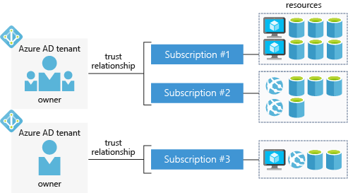

Notice that each Azure AD tenant has an *account owner*. This is the original Azure account that is responsible for billing. You can add additional users to the tenant, and even invite guests from other Azure AD tenants to access resources in subscriptions.

# Exercise - Create an Azure account

To create and use Azure services, you will eventually need an account. Remember, the account is free - you will not be charged for any services until you convert the account to a pay-as-you-go account.

You will need a valid credit card to create the account. **This is used for age and identity validation only**. Your card will not be charged until you decide to upgrade the free/trial account to a full subscription.

Important

This exercise is completely optional. You do not need an Azure account to go through most of the Microsoft Learn modules on Azure. If you already have an Azure account, or if you aren't ready to create one now, you can skip this unit.

## Sign up for a free account

1. In a web browser, navigate to [azure.microsoft.com](https://azure.microsoft.com/) , and click **Free Account**.
2. On the **Create your Azure free account today** page, click **Start free >** button.
3. Scroll down through the page - it lists the products you can access for free, as well as the free products available for the first year.
4. Click the **Start free >** button. You'll be prompted to sign in with your Microsoft account. Sign in with your Microsoft credentials or create a new free Microsoft account.
5. On the **About you** page, select your correct country or region, and then enter your first and last names, along with your email address and phone number. Depending on your country, you may see additional fields, such as a VAT number. Click **Next** to continue.
6. On the **Identity verification by phone** screen, select your country code, and type the number of a telephone to which you have immediate access.
7. You have the option of text or callback to obtain a verification code. Click the relevant button, type the code in the **Verification code** box, and click **Verify code**.
8. If the verification code is correct, you will now be asked to enter details of a valid credit card. Enter the card number, the expiration date, the CVV number, your name, and address, and click **Next**.
9. Finally, check the box to accept the subscription agreement, privacy statement, and communications policy. The second checkbox is optional. Now click **Sign up**.

Congratulations! You have now successfully set up a free account, and should be on the Azure portal home page.

For Student Account, there will be a different approach to register as students won't require a credit card. Instead, they will need to verify their student status first.

# Azure support options

One final thing to know about subscriptions is how to get support when you need it. Every Azure subscription includes free access to the following essential support services:

* Billing and subscription support
* Azure products and services documentation
* Online self-help documentation
* Whitepapers
* Community support forums

## Paid Azure support plans

Microsoft offers four paid Azure support plans for customers who require technical and operational support: Developer, Standard, Professional Direct, and Premier.

|  | **Developer** | **Standard** | **Professional Direct** | **Premier** |
| --- | --- | --- | --- | --- |
| Scope | Trial and non-production environments | Production workload environments | Business-critical dependence | Substantial dependence across multiple products |
| Technical Support | Business hours access to Support Engineers via email | 24x7 access to Support Engineers via email and phone | 24x7 access to Support Engineers via email and phone | 24x7 access to Support Engineers via email and phone |
| Case Severity/Response Times | Minimal business impact (Sev C): <8 business hours | Critical business impact (Sev A): <1 hour | Critical business impact (Sev A): <1 hour | Critical business impact (Sev A): <1 hour <15 minutes (with Azure Rapid Response or Azure Event Management) |
| Architecture Support | General guidance | General guidance | Architectural guidance based on best practice delivered by ProDirect Delivery Manager | Customer-specific architectural support such as design reviews, performance tuning, configuration, and more |
| Operations Support |  |  | Onboarding services, service reviews, Azure Advisor consultations | Technical account manager-led service reviews and reporting |
| Training |  |  | Azure Engineering-led web seminars | Azure Engineering-led web seminars, on-demand training |
| Proactive Guidance |  |  | ProDirect Delivery Manager | Designated Technical Account Manager |
| Launch Support |  |  |  | Azure Event Management (available for additional fee) |

Providing different Azure support options allows Azure customers to choose a plan that best fits their needs.

## Support-plan availability and billing

The support plans available and how you're charged depends on the type of Azure customer you are, and the type of Azure subscription you have.

For example, Developer support isn't available to Enterprise customers. Enterprise customers can purchase Standard, Professional Direct, and Premier support plans, and be billed for support as part of an Enterprise Agreement (EA). Alternatively, if you purchase a support plan within a pay-as-you-go subscription, your support plan is charged to your monthly Azure subscription bill.

## Other support options

Several additional support channels are available outside Azure's official support plans.

| **Channel** | **Description** |
| --- | --- |
| **Azure Knowledge Center** | The [Azure Knowledge Center](https://azure.microsoft.com/resources/knowledge-center/) is a searchable database that contains answers to common support questions, from a community of Azure experts, developers, customers, and users. You can browse through all responses within the Azure Knowledge Center. Find specific solutions by entering keyword search terms into the text-entry field and further refine your search results by selecting products or tags from the lists provided by two dropdown lists. |
| **Microsoft Developer Network (MSDN) Forums** | Get support by reading responses to Azure technical questions from Microsoft's developers and testers on the [MSDN Azure discussion forums](https://social.msdn.microsoft.com/Forums/home?category=windowsazureplatform). |
| **Stack Overflow** | You can review answers to questions from the development community on [StackOverflow](https://stackoverflow.com/questions/tagged/azure/). |
| **Server Fault** | Review community responses to questions about System and Network Administration in Azure on [ServerFault](https://serverfault.com/questions/tagged/azure). |
| **Azure Feedback Forums** | Read ideas and suggestions for improving Azure made by Azure users and customers on the [Azure feedback forums](https://feedback.azure.com/forums/34192--general-feedback). |
| **Twitter** | Tweet @AzureSupport to get answers and support from the [official Microsoft Azure Twitter channel](https://twitter.com/azuresupport). |

# Summary

We have covered several important topics in this module.

* You have learned about Azure accounts, subscriptions, and tenants.
* You have seen how billing and support are managed in Azure.
* You have created a free account for Microsoft Azure and learned how to sign in using that account.

## Learn more

Here are some places to go to learn more about what we've covered today:

* [Azure Free Account FAQ](https://azure.microsoft.com/free/free-account-faq/)
* [Manage your Azure account](https://azure.microsoft.com/account/)
* [Azure subscription limits and constraints](https://docs.microsoft.com/azure/azure-subscription-service-limits)
* [Azure support plans](https://azure.microsoft.com/support/plans/)
* [Community support channels](https://azure.microsoft.com/support/community/)